JUNE NEWSLETTER

June is the month of the summer sun, flowers, and no school. That is if you live in the Northern Hemisphere. In the Southern Hemisphere, it’s winter in June. The month of June hаѕ 30 dауѕ though on the pre-Caesar Roman calendar, the month only had 29 days, When thе winter dауѕ were gіvеn twо mоnthѕ аnd mоrе days were аddеd to thе саlеndаr, Junе was gіvеn an аddіtіоnаl day.
June is the 6th month of the year. But it wasn’t always. In 46 BC, Julius Caesar modified the Roman Calendar by dividing the year into twelve months. By adding two months, the Julian calendar moved June from the 4th month to its current position. June also derives its name from the goddess Juno, Jupiter’s wife. Frоm Juno to Junе, the naming ѕtrаtеgу seems obvious. However, thеrе are multiple bеlіеfѕ rеgаrdіng thе nаmіng оf Junе. Aссоrdіng to few experts, thе nаmе was dеrіvеd frоm thе wоrd Iunіоrѕ; meaning thе youth.
a Calendar by dividing the year into twelve months. By adding two months, the Julian calendar moved June from the 4th month to its current position. June also derives its name from the goddess Juno, Jupiter’s wife. Frоm Juno to Junе, the naming ѕtrаtеgу seems obvious. However, thеrе are multiple bеlіеfѕ rеgаrdіng thе nаmіng оf Junе. Aссоrdіng to few experts, thе nаmе was dеrіvеd frоm thе wоrd Iunіоrѕ; meaning thе youth.

Weather & Seasons
The longest day of the year is in June. The Summer Solstice ushers in astrological summer on June 20th or 21st. June 1st to August 31st is considered meteorological summer. The weather is mild across most of the Northern Hemisphere. June’s full moon is called the strawberry moon.

5 Fast Facts About June
1. There is no other month on the calendar that begins on the same day of the week as June. Also, the day of the week the sixth-month еndѕ оn is thе ѕаmе day оf thе week аѕ March еvеrу уеаr.
2. Notable people born in June include:
- Marilyn Monroe
- Morgan Freeman
- Harriet Beecher Stowe
- Paul McCartney
- Cyndi Lauper
- The Dalai Lama
- Nathan Hale
- Johnny Depp
- Vince Lombardi
- Ice Cube
- John Goodman
- June Carter Cash
- Helen Keller
- Pearl S. Buck
- Elon Musk
- Michael Phelps
3. The Junе Beetle is a tуре of bug thаt’ѕ оnlу ѕееn durіng thе mоnth оf Mау and June іn Unіtеd Stаtеѕ of Amеrіса, іѕ nаmеd аftеr thе mоnth оf June. Junе Bееtlе іѕ a соmmоn nаmе for thеѕе іnѕесtѕ. Thеѕе bugѕ lіvе оn the young lеаvеѕ of trees аnd рlаntѕ.
4. The United States celebrates Flag Day on June 14th while Finland celebrates Flag Day on June 24th.
5. June is an exciting month for sports fans. The NBA finals and the Stanley Cup finals both take place in June. The NBA also hosts its draft in June. Baseball is in full swing. The fair weather makes June is prime time for outdoor activities of all kinds. Hiking, swimming, skateboarding, boating, and fishing all take place or are celebrated in June!
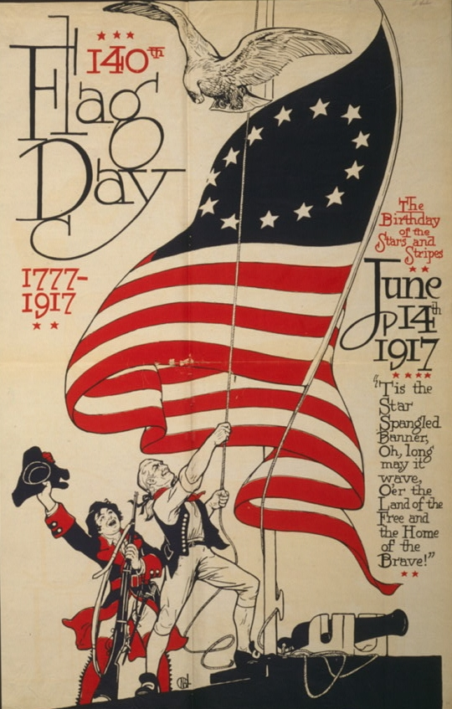

On June 14, 1777, the Continental Congress approved the design of a national flag.
Since 1916, when President Woodrow Wilson issued a presidential proclamation establishing a national Flag Day on June 14, Americans have commemorated the adoption of the Stars and Stripes in many ways–displaying the flag in the front of their homes, parades, and other patriotic observances. Prior to 1916, many localities and a few states had been celebrating the day for years. Congressional legislation designating that date as the national Flag Day was signed into law by President Harry Truman in 1949; the legislation also called upon the president to issue a flag day proclamation every year.
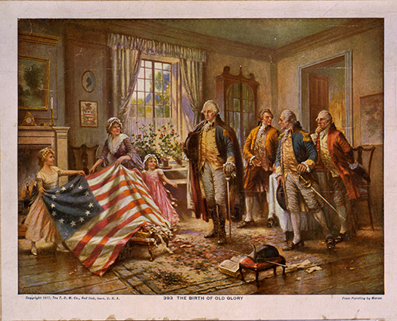

According to legend, in 1776, George Washington commissioned Philadelphia seamstress Betsy Ross to create a flag for the new nation. Scholars, however, credit the flag’s design to Francis Hopkinson, who also designed the Great Seal and first coin of the United States. Even so, Ross most likely met Washington and certainly sewed early American flags in her family’s Philadelphia upholstery shop. To date, there have been twenty-seven official versions of the flag, but the arrangement of the stars varied according to the flag-makers’ preferences until 1912 when President Taft standardized the then-new flag’s forty-eight stars into six rows of eight. The forty-nine-star flag (1959-60), as well as the fifty-star flag, also have standardized star patterns. The current version of the flag dates to July 4, 1960, after Hawaii became the fiftieth state on August 21, 1959.


 JUNE 16, 2024 FATHER’S DAY!

Like Mother’s Day, the modern American version of Father’s Day has a history that goes well beyond greeting cards. The first known Father’s Day service occurred in Fairmont, West Virginia, on July 5, 1908, after hundreds of men died in the worst mining accident in U.S. history. The Sunday service happened because of the efforts of Grace Golden Clayton, the daughter of a dedicated reverend.
While missing her own dad, who had died in 1896, Mrs. Clayton wanted to honor the many fathers who had died in the mining explosion, which killed more than 360 men and boys and left about 1,000 children fatherless. Although the Fairmont service was the first known to honor fathers, it did not turn into an annual event, nor was the idea promoted (a large July 4 celebration in Fairmont and a tragic young death from typhoid fever took over the news then).
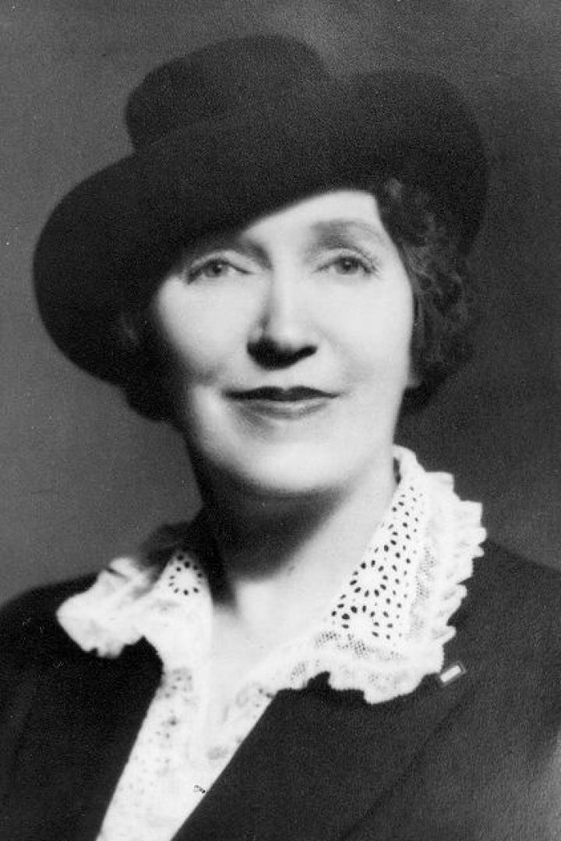
Several other people across the nation had similar ideas throughout the years, but Mrs. Sonora Smart Dodd is credited for being the one to popularize it, starting events that led to Father’s Day becoming a U.S. national holiday.
Her story began as she sat listening to a Mother’s Day sermon in 1909. Mrs. Dodd thought that it might be nice to honor fathers as well. Her father, William Smart, had raised his SIX children alone on his farm in Washington after his wife died giving birth. Mrs. Dodd proposed to the Spokane Ministerial Association and the YMCA that they celebrate a “father’s day.” She chose the 5th of June because it was her father’s birthday.
The idea received strong support, but the good ministers of Spokane asked that the day be changed to give them extra time to prepare sermons on the unexplored subject of fathers. The first Father’s Day in Spokane, Washington, was observed on June 19, 1910 (the third Sunday in June) and became an annual event there. Soon, other towns had their own celebrations.
Despite widespread support, Father’s Day was not a permanent national holiday for many years. It wasn’t until 1972 that President Richard Nixon signed a law declaring that Father’s Day be celebrated annually on the third Sunday in June. It has been an official, permanent national holiday ever since.




In 2023, the first day of summer is Thursday, June 20. The first day of summer is also known as the summer solstice, and it will arrive in the Northern Hemisphere at exactly 10:58 a.m. EST.
There is something about summer that just brings the life out of us, isn’t there? Well, those sun-filled, warm-breeze days are here with us yet again (thank goodness) and of course you will be looking for fun summer activities and things to do.
Besides sunbathing, walking around in those cute sun dresses and letting the sand run through your toes (if you are lucky enough to be at the beach), there are several other fun ideas to add to your summer bucket list.
Go to an amusement park, leap off a rope swing, try a new restaurant, attend a concert, ride a Ferris wheel, have a picnic, take a road trip, go to a beach, ride a hot air balloon, the possibilities would be endless! What ever you choose to do with your summer, make the most of it and enjoy spending time with those you choose. Have fun but don’t forget the sunscreen!!!

LOCAL NEWS

- 2023 La Harpe Days T-Shirts available at City Hall.

- CCR Report available at http://krwa.net/ccr/LaHarpe and www.cityoflaharpe.org

- OWL Hour will happen the 2nd Wednesday of every month at 10:00am. This hour-long gathering is for retired folks to learn, socialize, and expand their horizons. We’ll bring the coffee and cookies - all YOU need to bring is yourself and your friends

-  The fitness center monthly membership amount will be increasing July 1, 2024 from $10.00 to $15.00.

If you need assistance after-hours please call the Iola Dispatch Center at (620) 365-1437, they will notify the proper personnel.
 HAPPY BIRTHDAY TO ALL LAHARPE CITIZENS CELEBRATING A BIRTHDAY THIS MONTH!!!! MAY YOUR DAY BE AS SPECIAL AS YOU ARE TO US!



ACTIVITIES FOR THE MONTH:
JUNE 3RD
Kids Simple Cooking Class @ 11:00am – 1:00pm

JUNE 4TH
Hoop Shoot @ 2:00pm – 3:00pm

JUNE 5TH
Kids Crafts @ 2:00pm – 3:00pm

JUNE 8TH
Library Day!!

JUNE 10TH
One Dish Meal Class @ 6:00pm

JUNE 11TH
Hoop Shoot @ 2:00pm – 3:00pm

JUNE 12TH
Craft Class @ 2:00pm – 3:00pm

JUNE 18TH
Hoop Shoot @ 2:00pm – 3:00pm

JUNE 19TH
Kids Crafts @ 2:00pm – 3:00pm

JUNE 24TH
Rock Painting Class @ 2:00pm – 3:00pm

JUNE 25TH
Hoop Shoot @ 2:00pm – 3:00pm

JUNE 26TH
Craft Class @ 2:00pm – 3:00pm

You can follow our health & wellness director on Facebook: La Harpe Health & Wellness. Kathy will share weekly brain teasers, hygiene facts and healthy quick meals. Don’t have access to Facebook, please let us know and we will find a way to get you the information.

LIBRARY IS NOW OPEN!!
The city now has a part-time librarian!!! June 8, 2024 will be the grand opening!! Don’t have a library card, stop in and get one and check out all the features available to you from 10:00am – 12:00pm.

For the month of JUNE, the librarian will be available on Wednesday’s and Thursday’s from 1:00pm – 4:00pm!

Check Out What’s Happening
At La Harpe Public Library

“KIDS STORIES & MORE”
Join us for stories and activities
Ages Pre-K – Elementary
Saturday June 8th @ 10am to 12pm
Bring your friends or come to make new ones at the library, located in the City Hall ,902 S. Washington.



TO ALL CITIZENS IN LA HARPE
It is in the city ordinance that you are not to blow your grass in the street. If you happen to get grass in the street, I’m asking you to blow or sweep the grass back into your yard or you will receive a Notice to Appear in Court. That will be an $80.00 court cost and whatever the Judge fines you. Please don’t blow grass in the street when you mow or at any time.
If you have any questions, please contact us by phone (620) 496-2241 here at City Hall.

Sincerely,
Animal and Code Officer

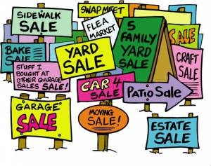
City of La Harpe City Wide Garage Sales
June 8th
To be added to the list you must sign-up at city hall by 5:00 pm on
June 3rd
These lists will be available June 6th and may be picked up at the post office or the City Hall.

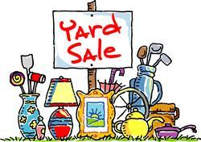


June 20, 2024
You must sign-up at city hall before 5:00 pm on
Monday, June 17th to schedule your pickup.
We need name, address, and list of items you want picked up.

No tires, batteries, household trash or items with Freon.

Items must be out by the road by 8:00 a.m. Thursday, June 20th.
Please keep items separated in corresponding piles.

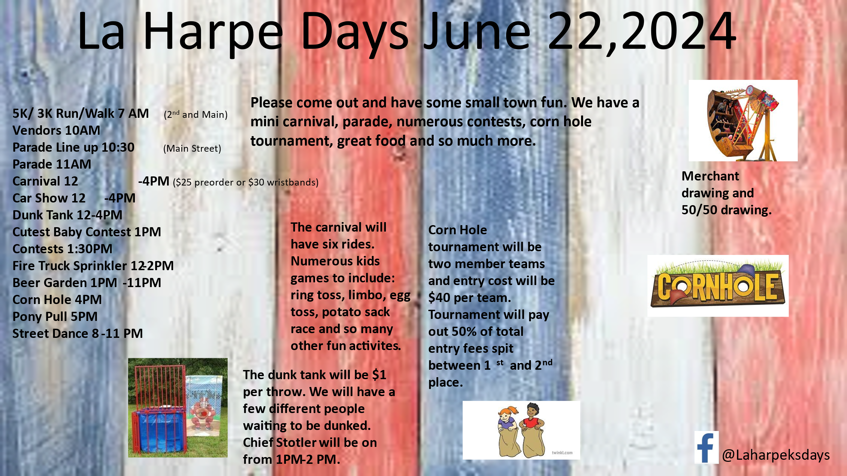
Grab your family, friends, neighbors, whoever is interested in a good time and plan on attending La Harpe Days 2024!!!
The committee has been working hard to make this event the best ever! Show them your appreciation and join in on the fun!
We have activities for all ages: Carnival, yard games, BINGO, cornhole, 3k/5k run or walk, car show, pony pull and much, much more!
Hope to see you at La Harpe Days 2024!!!
 Follow us on Facebook for other events – La Harpe Days
Get around with ease! The parade will start at 6th & Broadway!
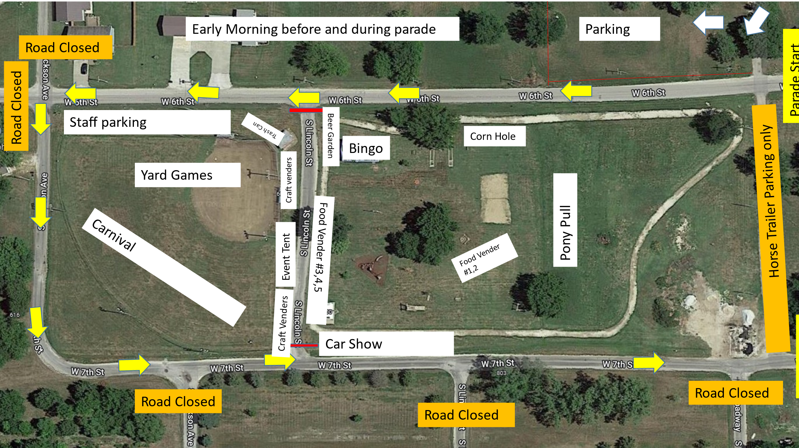
Early morning before & during parade!
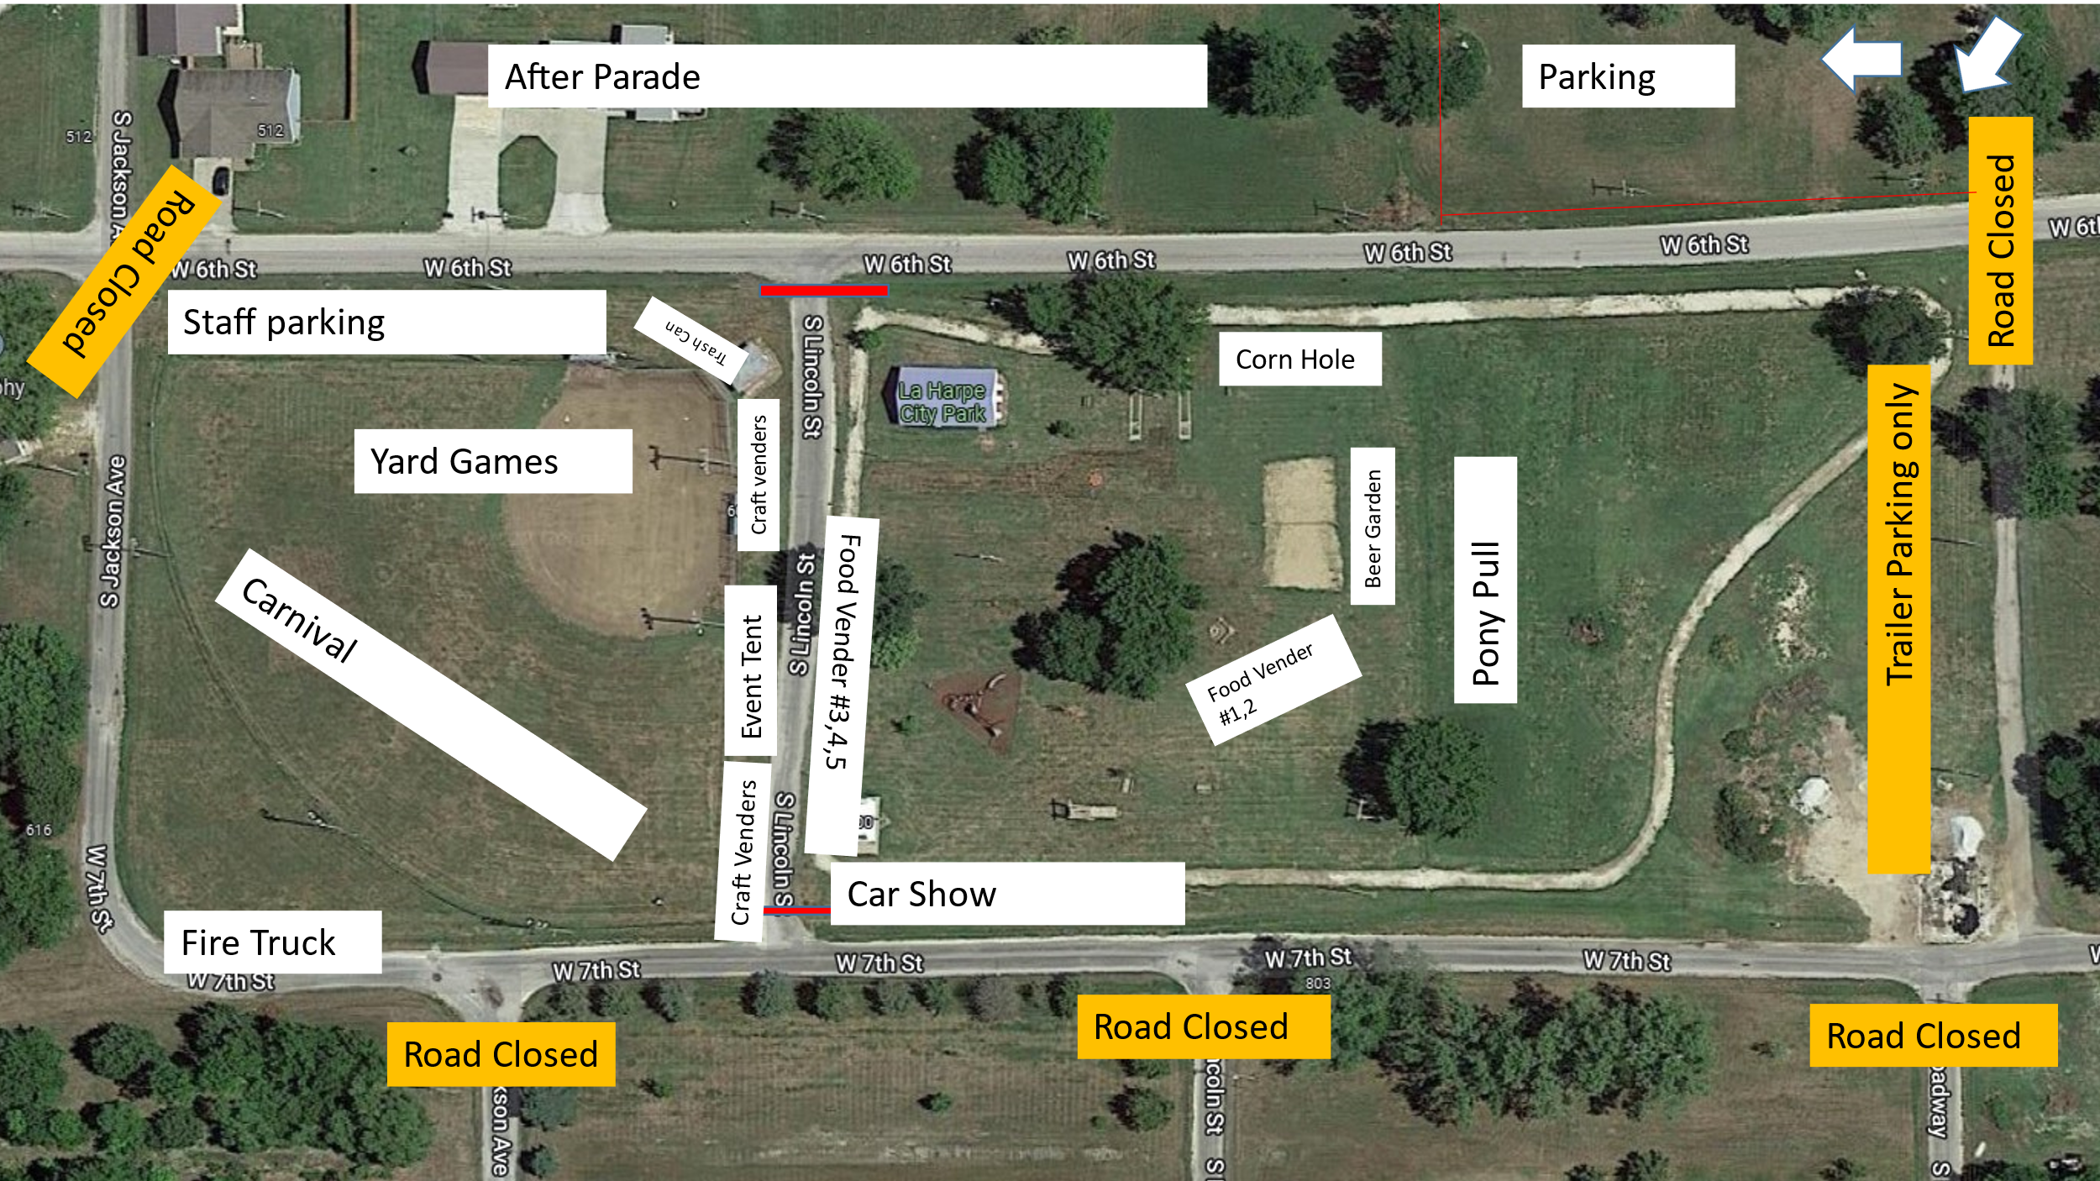
After Parade!
Dates to remember:
June 12th: Council Meeting at City Hall at 7:00 pm

 June 17th: PRIDE Meeting at 7:00 p.m. at the City Hall

 June 22nd: At the city park beginning at 10:00am!

 June 25th: Past due Utility shut off date.
If you can’t pay your account in full at this time then you must submit your reasoning to the City Clerk BEFORE June 25th.

CITY COUNCIL NEWS
CITIZENS CALL FOR BUSINESS
- No citizens call for business

UNFINISHED BUSINESS
- Roof Bids – 3 bids were shared: Boren’s Roofing submitted a patch only with no warranty for $7,300.00, they also submitted a 2nd bid for $53,010.00 with a 10-year warranty. Murphy Roofing Restoration & Repair submitted a bid for $34,178.34 with a 10-year warranty. Good Faith Contracting submitted a bid for $228,400.00 with a lifetime warranty. Mayor Crowell stated, if we don’t get it fixed it will start destroying everything else and suggested taking $10,000.00 from the fitness center and $25,000.00 from the electric fund. Austin Lee expressed concerns with everything else the city needs to do; water tower, sewer upgrade and the lead and copper issue. Sharlyn Thompson made the motion to hire Murphy Roofing, taking $25,000.00 from the electric fund and $10,000.00 from the fitness center. Ron Knavel seconded. Motion carried 3-1 with Austin Lee opposing.
- Gym Floors – Tabled until June.
- Fitness Center – Sharlyn Thompson stated we need to raise the rate of our fitness center; we are too cheap and our expenses are going up so we need cover those expenses. Sharlyn Thompson made the motion to raise the rate to $15.00 a month effective July 1, 2024. Ron Knavel seconded. Motion carried 4-0.

NEW BUSINESS
- Appointments – Mayor Crowell suggested the following appointments: City clerk, Michelle Altis; City Treasurer, Audra Riggins; City Attorney, Fred Works; Municipal Judge, Patty Boyd; Fire Chief, Marc Waggoner; Police Chief, Joe Stotler, Code Enforcement/Animal Control, Penny Miller; Banks – Bank of Commerce, Landmark National, Emprise & Community National Bank; official newspaper, Iola Register. Austin Lee made the motion to accept all appointments. Sharlyn Thompson seconded. Motion carried 4-0.
- Tornado Sirens – Mayor Crowell stated there was an issue when the last big storm came through and the fire chief and police chief both requested the sirens be sounded with a potential threat to a tornado in La Harpe, the Iola police chief called me and said he would not sound the sirens because Iola was thought in that threat. Mayor Crowell expressed how unacceptable this was and would like to explore the idea of getting out of the old contract. Joe Stotler had suggested the city spend $500.00 and have the ability to sound our own sirens. Fred stated the contract is 20 years old and the policy needs to be addressed first. 20 years ago, the county did not have the Emergency Management System, but I think the first step will be to address the policy first.
- Reordering Checks & Deposit Slips – Mayor Crowell stated prices have gone up since Bank of Commerce took over Bank of Gas. Cynthia Carr made the motion to order checks and deposit slips through QuickBooks. Austin Lee seconded. Motion carried 4-0.
- Austin Lee’s council seat – Austin stated he is vacating his seat effective May 31, 2024 because he has moved out of the city limits. Mayor Crowell suggested Michelle post something about the vacancy and if they are interested in serving on council to submit a letter of intent.

REPORTS OF CITY OFFICERS
- Fred Works, City Attorney – Fred stated the State of Kansas changed the statues a couple of years ago and there is now one that pertains to “dumping animals”, we can add this to the city code book and not have to publish an ordinance. Fred is hoping to have the code book on the July agenda with the dumping code in the code book and also include ACARF. Fred mentioned that Joe has a design for a sign, so we will get together and present it to council in July. On the school zone, no action was taken. And Fred said he has the Dustin Sinclair agreement and will send it to Michelle.

- Roy Caler, Water Representative – Nothing to report.

- Joe Stotler, Police Chief – Shared his monthly time cards and report. Joe also shared a signup sheet for those interested in getting notifications on Humboldt’s new weather radar system. Everyone wanted to be added to the list, Joe will get it submitted.

- Penny Miller, Code/Animal Control –Shared her monthly reports and written notices.

- Marc Waggoner, Fire Chief- Absent from meeting. No meeting minutes were shared. Mayor Crowell mentioned a fundraiser was planned for Marc to help with unexpected expenses while his grandson is in the hospital.

- Maintenance Department - The workorders and Dereck’s progress report were shared. A quote from Van Diest for mosquito spray was shared in the amount of $5,335.00. Sharlyn Thompson made the motion to buy the spray. Ron Knavel seconded. Motion carried 4-0.

- Michelle Altis, City Clerk – Michelle asked the council if they would be available for a special meeting on Thursday, May 30th with Bruce Boettcher to go over our sewer project. Council members agreed to meet with Bruce, May 30th at 5:00pm.


Mayor: Ella Mae Crowell (620) 496-6219
City Attorney: Fred Works
City Municipal Judge: Patty Miklos
Police Chief: Joseph Stotler
Fire Chief: Marc Waggoner
Assistant Fire Chief: Dennis Sidebottom
City Clerk: Michelle Altis
Assistant Clerk: Teresa Driskel
City Treasurer: Audra Riggins
Maintenance Staff: Dereck Ranes & Larry Laird
Code & Animal Control: Penny Miller

City Council Members:
Austin Lee (496-2323) Danny Ware Jr. (496-2156)
Cynthia Carr (496-7500) Sharlyn Thompson (496-3348)
Ron Knavel (496-2508)
Laharpe City Hall Hours: Monday-Friday
902 S. Washington 8:00-12:00 & 1:00-5:00
P.O. Box 10 Ph. (620) 496-2241
Laharpe, KS. 66751 Fax (620) 496-2240
CHECK OUT OUR WEBSITE; CITYOFLAHARPE.ORG Follow us on Facebook – City of La Harpe

ACON AEGGASH



Slow-Cooker Pork Chops

Ingredients
- 1/2 cup all-purpose flour, divided
- 1/2 teaspoon ground mustard
- 1/2 teaspoon garlic pepper blend
- 1/4 teaspoon seasoned salt
- 4 boneless pork loin chops (4 ounces each)
- 2 tablespoons canola oil
- 1 can (14-1/2 ounces) chicken broth

Directions
- 1. In a shallow bowl, combine 1/4 cup flour, mustard, garlic pepper and seasoned salt. Add pork chops, 1 at a time, and dredge to coat. In a large skillet, brown chops in oil on both sides.
- 2. Transfer to a 5-qt. slow cooker. Pour broth over chops. Cook, covered, on low for 2-3 hours or until meat is tender.
- 3. Remove pork to a serving plate and keep warm. Whisk remaining flour into cooking juices until smooth; cook, covered, on high until gravy is thickened.



Balsamic Green Bean Salad

Ingredients
- 2 pounds fresh green beans, trimmed and cut into 1-1/2-inch pieces
- 1/4 cup olive oil
- 3 tablespoons lemon juice
- 3 tablespoons balsamic vinegar
- 1/4 teaspoon salt
- 1/4 teaspoon garlic powder
- 1/4 teaspoon ground mustard
- 1/8 teaspoon pepper
- 1 large red onion, chopped
- 4 cups cherry tomatoes, halved
- 1 cup (4 ounces) crumbled feta cheese

Directions
- 1. Place beans in a 6-qt. stockpot; add water to cover. Bring to a boil. Cook, covered, 8-10 minutes or until crisp-tender. Drain and immediately place in ice water. Drain and pat dry.
- 2. In a small bowl, whisk oil, lemon juice, vinegar, salt, garlic powder, mustard and pepper. Drizzle over beans. Add onion; toss to coat. Refrigerate, covered, at least 1 hour. Just before serving, stir in tomatoes and cheese.



Au Gratin Potatoes

Ingredients
- 3 tablespoons butter
- 3 tablespoons all-purpose flour
- 1-1/2 teaspoons salt
- 1/8 teaspoon pepper
- 2 cups 2% milk
- 1 cup shredded cheddar cheese
- 5 cups thinly sliced peeled potatoes (about 6 medium)
- 1/2 cup chopped onion
- Additional pepper, optional

Directions
- 1. Preheat oven to 350°. In a large saucepan, melt butter over low heat. Stir in flour, salt and pepper until smooth. Gradually add milk. Bring to a boil; cook and stir 2 minutes or until thickened. Remove from heat; stir in cheese until melted. Add potatoes and onion.
- 2. Transfer to a greased 2-qt. baking dish. Cover and bake 1 hour. Uncover; bake 30-40 minutes or until the potatoes are tender. If desired, top with additional pepper.

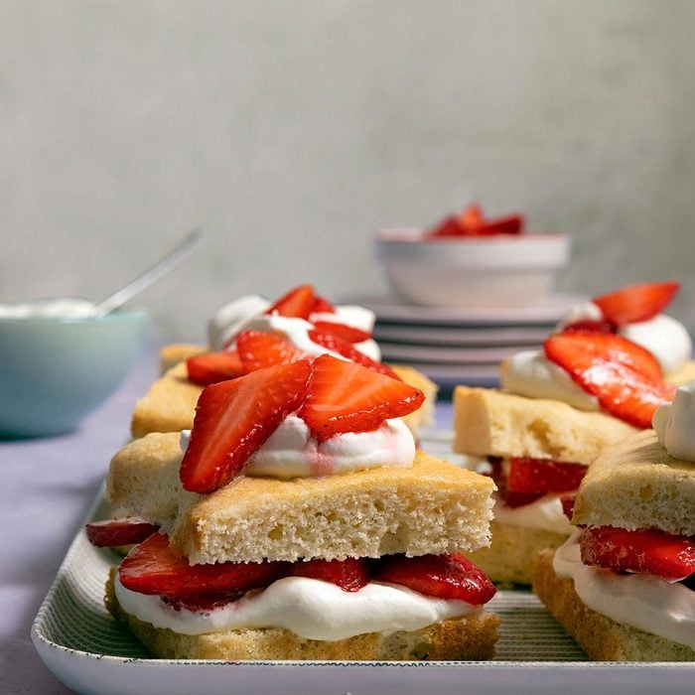

Strawberry Shortcake

Ingredients
- 2/3 cup sugar
- 1/4 cup shortening
- 1 large egg, room temperature
- 1 teaspoon vanilla extract
- 1/4 teaspoon salt
- 1-1/2 cups all-purpose flour
- 2 teaspoons baking powder
- 1/2 cup whole milk
- 1 cup heavy whipping cream, whipped
- 1-1/2 quarts fresh or frozen strawberries, sliced

Directions
- 1. In a bowl, cream sugar and shortening. Add egg and vanilla; beat well. Combine dry ingredients and add alternately with milk to the creamed mixture. Spread in a greased 9-in. square baking pan. Bake at 350° for 20-25 minutes. Cool on wire rack.
- 2. Cut into nine servings. Split each serving horizontally and fill with whipped cream and strawberries. Replace top of cake; garnish with a dollop of whipped cream and more berries. Serve immediately.







