MAY NEWSLETTER

 

May is known as a month of transition. If you live in the northern hemisphere, the fresh cold winds are gone, as are the rains of early spring.

By the time May comes around, the spring flowers are blooming, birds are chirping, and life is starting to seem a little more joyful day by day!

If you’re on the other side of the world, in the southern hemisphere, then it’s a time when summer is long gone. The fall winds have swept by, and the nights are getting colder and darker.

It’s a time of change, yet still delightfully warm.

Again, May is a time of change, no matter where in the world you are.

What is it about May that’s so significant though? Let’s take a look at this a-may-zing month!

1. The name May is the modern-day English adaption of the Latin word Maius, which has origins going back to the time of the ancient Greeks. They named the month of May (or Maius) after the Greek goddess of growth.
2. A Roman poet by the name of Ovid had different ideas surrounding the etymology of the naming of May. He claimed that it was from the word Maiores, the Latin for “elders,” that the month gained its name.
3. The word May wasn’t actually used until the Middle Ages were on their way out, around the 15th Century AD. Up until then, the Roman word Maius was still used.
4. May used to have a very different name in Old English. Back then, the month was referred to as the “month of three milkings.” Unsurprisingly, this meant that during this month, you could [milk](https://www.thefactsite.com/milk-facts/) your cows up to three times per day!
5. May was once considered an incredibly ill-omened time to get married. There’s an adage for it actually, which goes: “Marry in May and you’ll rue the day.” It’s not clear where exactly the saying comes from, but there must have been a pretty good reason not to get married in one of the most beautiful months of the year!
6. May isn’t just a bad time to get married, though. There’s the Cornish superstition that buying a new broom in May is unlucky. Oh, and apparently, you shouldn’t wash any blankets either!
7. May is the month that the Eurovision song contest is held every year. For those not in the know, Eurovision is an international song contest that has been held every year since 1956. Some of the contest winners over the years have gone on to be incredibly successful groups, with the most notable being ABBA!
8. May is a special time for [**Star Wars**](https://www.thefactsite.com/tag/star-wars/)fans worldwide and always a good reason to re-watch the movies. May the 4th is celebrated as Star Wars day, due to the way the date sounds similar to “May the Force.” We won’t start the debate over whether the old movies are better than the new ones, because we all know the answer to that!
9. Every year there is a particular meteor shower in May called the Eta Aquariids meteor shower. Discovered in 1870, this meteor shower passes by [Earth](https://www.thefactsite.com/facts-about-earth/) between [April 19](https://www.thefactsite.com/day/april-19/) and [May 28](https://www.thefactsite.com/day/may-28/). It’s easiest to view it from the equatorial regions of the world and can be glimpsed passing by just before dawn.
10. It is said that those born in May have a greater chance of being more successful in life and experience more love. While this may not be scientifically factual, it has been noticed that people born in May understand the importance of love and success more than others.
11. The Empire State Building opened its doors on [May 1, 1931](https://www.thefactsite.com/day/may-1/). At the point of its construction, it held the record for being the tallest building in the world. Many other sky-high constructions have since dwarfed it, but it’s still an awe-inspiring feature of the New York cityscape!
12. Back in the day in Europe, it wasn’t a good May if you didn’t celebrate it with a maypole. In the UK, at least, they were present since at least 1350 AD. Celebrants would erect a long pole and attach flowers, garlands, and strips of fabric to it, around which certain dances would take place.
13. May is a pretty good month for [US presidents](https://www.thefactsite.com/43-unbelievable-facts-about-our/). Every other month of the year, at least one US president has died, but never in May!
14. May is pretty exclusive when it comes to days of the week. No other month in one single year starts or finishes on the same weekday as May. Basically, if the first of May is on a [Friday](https://www.thefactsite.com/friday-facts/), and the 31st of May is on a Sunday, no other months in the year will start or end on a Friday or a [Sunday](https://www.thefactsite.com/sunday-facts/)!
15. The birthstone for May is the emerald. Emeralds are a type of stone called beryl and typically range from a deep-sea green to a lighter color. Emeralds are symbols of fertility and rebirth.
16. May actually has two birth flowers – the Lily-of-the-Valley and the Hawthorn. The Hawthorn flower is a symbol of hope, while the Lily-of-the-Valley represents the return of happiness and sweetness.
17. May also has two Zodiac signs, Taurus and Gemini. People born under the sign of Taurus are said to be ambitious and smart, yet trustworthy. Those born under the sign of Gemini are said to be passionate, adaptable, and smart.
18. May has some pretty interesting month-long observances. In the U.K., May is National Pet Month and National Smile Month. In the US, May is National Burger Month, Older Americans Month, and National Military Appreciation Month.
19. May also has some pretty wacky days! [Hawaii](https://www.thefactsite.com/interesting-hawaii-facts/) celebrates Lei Day on the first of May, which also happens to be [May Day](https://www.thefactsite.com/may-day-celebrations/). Utah celebrates Golden Spike Day on [May 10th](https://www.thefactsite.com/day/may-10/) after the First Transcontinental Railroad was completed. [May 29th](https://www.thefactsite.com/day/may-29/) is celebrated as [Put a Pillow on Your Fridge Day](https://www.thefactsite.com/put-pillow-on-your-fridge-day/)!
20. Many famous people were born in May, such as Mark Zuckerberg, Karl Marx, Clint Eastwood, Wes Anderson, John F. Kennedy, Queen Victoria, and Catherine the Great!

As you can see, May isn’t just a fantastic time of the year for weather – it’s also got some pretty cool history.

As the fifth month of the year, it would be so easy for it to slip by without notice, if not for all the interesting observances throughout the month!

## 11 Fun Facts for Mother's Day - Eastern Floral - Eastern Floral When is Mother's Day in 2024?

In case you didn't know: **Mother's Day is on Sunday, May 12, 2024**.

Is this the first time you're hearing of this? Don't sweat it! Unlike other holidays such as Christmas or Halloween, Mother's Day doesn't fall on a specific date every year. Instead of trying to remember it that way, think of it like this: Mother's Day **always**falls on the second Sunday of May!

## Why do we celebrate Mother's Day?

Ah, another great question! The [history of Mother's Day](https://www.thepioneerwoman.com/holidays-celebrations/a43555198/mothers-day-history/) is quite sweet! But to meet the "mother" of Mother's Day, you're going to have to travel all the way back in time to 1864—the year when Anna Jarvis was born.

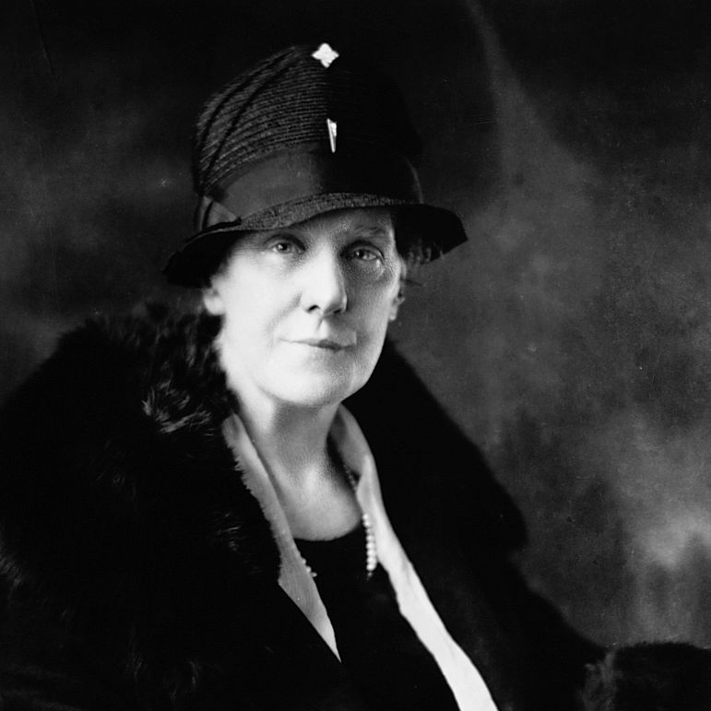 **Anna Jarvis (1864-1948), the American woman who campaigned for the holiday of Mother's Day.**

Anna was a determined activist, and to this day, she's credited with "inventing" Mother's Day in an attempt to honor her own mother, Ann Jarvis. Ann—that's Anna's mother—had spent much of her life raising awareness about the infant mortality rate. According to [*National Geographic*](https://www.nationalgeographic.com/news/2014/5/140508-mothers-day-nation-gifts-facts-culture-moms/), in the 1850s, she began hosting clubs for fellow mothers to teach them to better care for their children and curb those numbers.

When Ann passed away in 1905, Anna decided that a national "Mother's Day" would be a beautiful way to honor these noble efforts. [The History Channel](https://www.history.com/topics/holidays/mothers-day) notes that she hosted the first-ever Mother's Day function on May 10, 1908 in her hometown of Grafton, West Virginia, and that it was followed by a similar event in Philadelphia attended by "thousands of people."

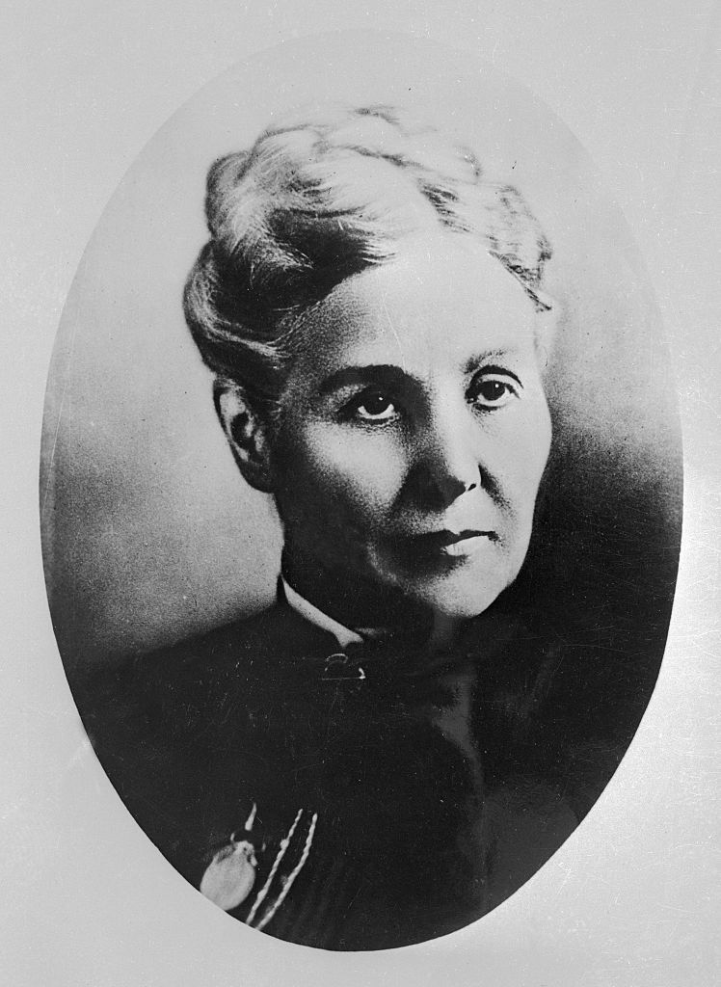 **Ann Jarvis, the mother of Anna Jarvis.**

As the story goes, President Woodrow Wilson's cabinet eventually got wind of Anna's work, and it was under his guidance that Mother's Day officially became a national holiday in 1914. At that time, it was also decided that the celebration would take place on the second Sunday in May each year.

Of course, Mother's Day as we know it today has very little to do with Anna's initial efforts or her mother's meaningful charity work. Bouquets of flowers and greeting cards were never part of the plan; in fact, Anna called the manufacturers of such products "schemers" and "profiteers," says [*BuzzFeed*](https://www.buzzfeed.com/joeloliphint/anna-jarvis-was-sorry-she-ever-invented-mothers-day), and allegedly told a Reader's Digest reporter that she "was sorry she had ever started Mother's Day."





Technically, though, it's still unclear if the idea of Mother's Day really belonged to the Jarvis women. Julia Ward Howe, the writer behind "The Battle Hymn of the Republic," had promoted a "Mothers' Peace Day" all the way back in 1872 as part of her antiwar efforts.

It's a toss-up, really.

But flowers, greeting cards, and competing historical narratives aside, there's something undeniably beautiful about the idea of setting aside an entire day to pay your respects to the woman who made you, well, you. The heart of the holiday remains special—no matter how much commercialization swirls around it. And that's a fact.





National Memorial Day in the USA is celebrated on the last Monday in May.  
All men and women, who gave their lives while serving in the United States Armed Forces, are commemorated on this day. National Memorial Day is formally known as Decoration Day, the day that commemorated the Union and Confederate soldiers, who died during the American Civil War. Later the day extended to honor all American soldiers, who died while in the military service.

Traditionally, the flag of the USA is raised briskly to the top of the flagstaff, then it is lowered to the half-staff position. This position is chosen in remembrance of those people, who died for their country. At noon the flag is raised to full-staff as the symbol that the memory of dead soldiers is being raised by the living. Their sacrifice was not in vain, that is why we rise up in their honor and continue fighting for liberty and justice.

Thousands of parades are held during National Memorial Day in all large and small cities. Most parades feature marching bands, servicemen, veterans and military vehicles from various wars also participate.

 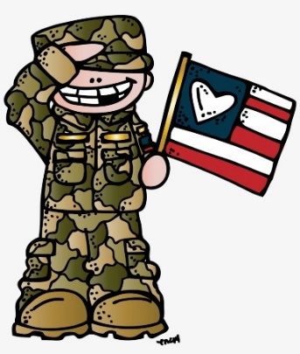

Originally called Decoration Day, from the early tradition of decorating graves with flowers, wreaths and flags, Memorial Day is a day for remembrance of those who have died in service to our country. It was first widely observed on May 30, 1868 to commemorate the sacrifices of Civil War soldiers, by proclamation of Gen. John A. Logan of the Grand Army of the Republic, an organization of former Union sailors and soldiers.

During that first national commemoration, former Union Gen. and sitting Ohio Congressman James Garfield made a speech at Arlington National Cemetery, after which 5,000 participants helped to decorate the graves of the more than 20,000 Union and Confederate soldiers who were buried there.

This national event galvanized efforts to honor and remember fallen soldiers that began with local observances at burial grounds in several towns throughout the United States following the end of the Civil War, such as the May 1, 1865 gathering in Charleston, South Carolina organized by freed slaves to pay tribute and give proper burial to Union troops.

In 1873, New York was the first state to designate Memorial Day as a legal holiday. By the late 1800s, many more cities and communities observed Memorial Day, and several states had declared it a legal holiday.

After World War I, it became an occasion for honoring those who died in all of America’s wars and was then more widely established as a national holiday throughout the United States.

In 1971, Congress passed the Uniform Monday Holiday Act and established that Memorial Day was to be commemorated on the last Monday of May. Several southern states, however, officially commemorate an additional, separate day for honoring the Confederate war dead, sometimes referred to as a Confederate Memorial Day: January 19 in Texas; third Monday in Jan. in Arkansas; fourth Monday in Apr. in Alabama and Mississippi; April 26 in Florida and Georgia; May 10 in North and South Carolina; last Monday in May in Virginia; and June 3 in Louisiana and Tennessee.

Memorial Day is commemorated at Arlington National Cemetery each year with a ceremony in which a small American flag is placed on each grave. Traditionally, the President or Vice President lays a wreath at the Tomb of the Unknown Soldier. About 5,000 people attend the ceremony annually.

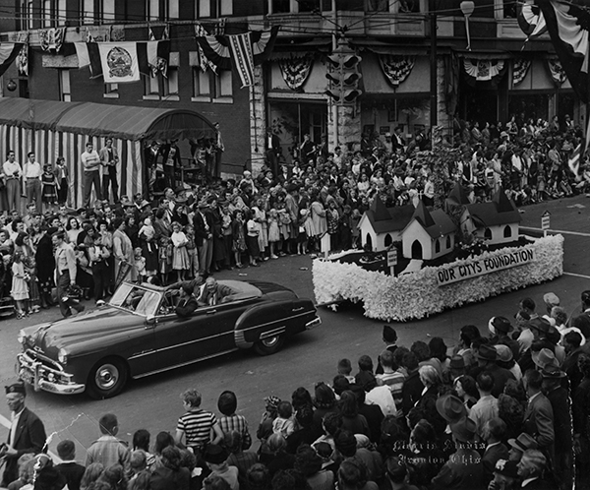



***THANK YOU TO ALL MEN AND WOMEN WHO HAVE SERVED OR ARE STILL SERVING OUR COUNTRY.***

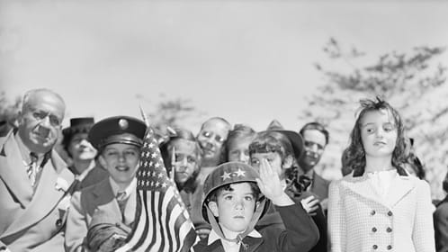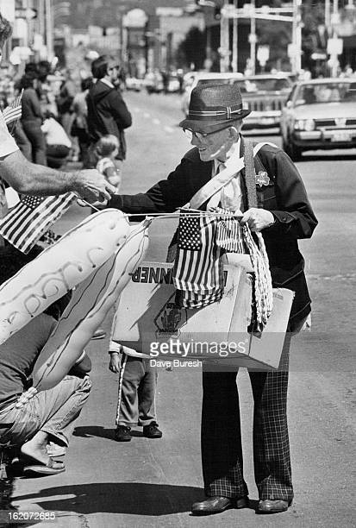

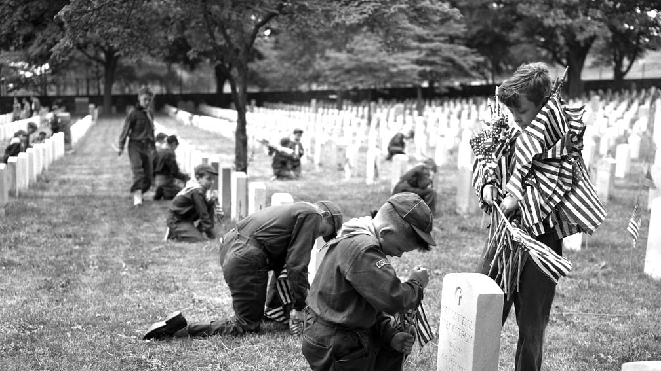

 

### Graduation Clipart Images - 8th Grade Graduation Clip Art - Free Transparent PNG Clipart Images Download

**Congratulations to the Class of 2024!!!**



 LOCAL NEWS

* Are you in need of grocery delivery service? Call 620-228-5570 for more information on this new service.
* La Harpe Days T-Shirts available at City Hall.

**If you need assistance after-hours please call the Iola Dispatch Center at (620) 365-1437, they will notify the proper personnel.**

 **HAPPY BIRTHDAY TO ALL LAHARPE CITIZENS CELEBRATING A BIRTHDAY THIS MONTH!!!! MAY YOUR DAY BE AS SPECIAL AS YOU ARE TO US!**

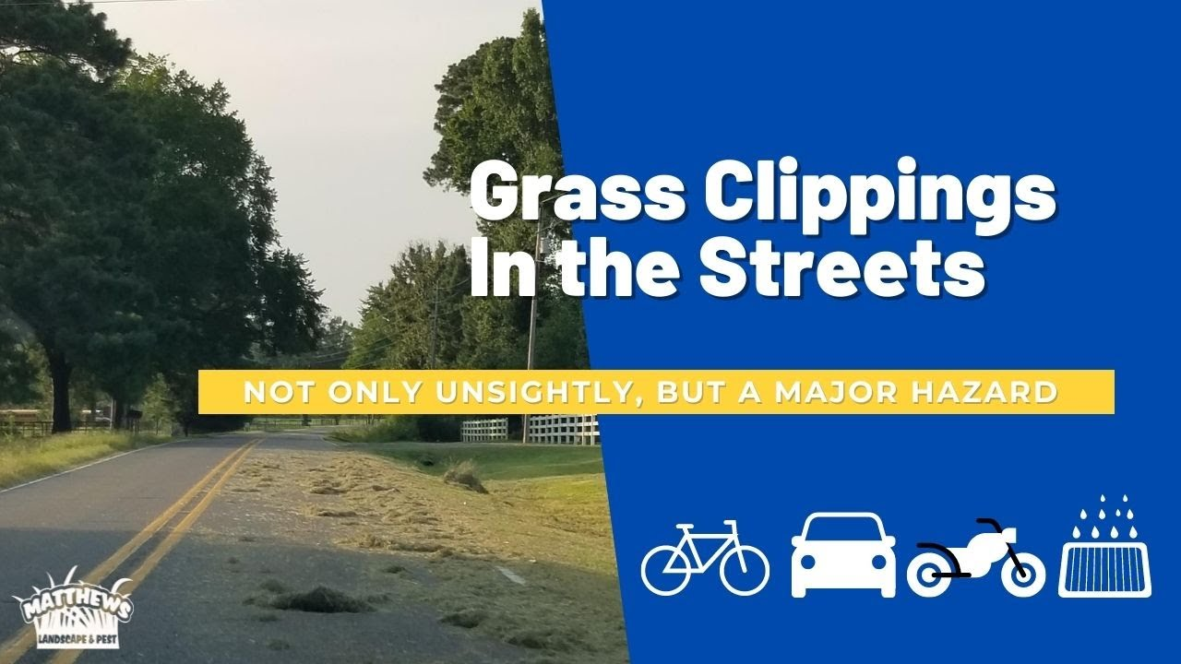

**TO ALL CITIZENS IN LA HARPE**

**It is in the city ordinance that you are not to blow your grass in the street. If you happen to get grass in the street, I’m asking you to blow or sweep the grass back into your yard or you will receive a Notice to Appear in Court. That will be an $80.00 court cost and whatever the Judge fines you. Please don’t blow grass in the street when you mow or at any time.**

**If you have any questions, please contact us by phone (620) 496-2241 here at City Hall.**

**Sincerely,**

**Animal and Code Officer**



**ACTIVITIES FOR THE MONTH:**

**MAY 1ST**

Plant Planting Class @ 5:00pm

**MAY 6TH**

Dodgeball @ 6:00pm

**MAY 9TH**

Flower Painting Class 6:00pm

**MAY 13TH**

Crockpot/One Dish Class @ 6:00pm

**MAY 15TH**

Craft Class @ 6:00pm

**MAY 21ST**

Walk and Talk @ 6:00pm

**MAY 23RD**

Cornhole @ 6:00pm

**MAY 28TH**

Walk and Talk @ 6:00pm

**MAY 30TH**

Kids Dance until Crazy @ 6:00pm

*You can follow our health & wellness director on Facebook: La Harpe Health & Wellness. Kathy will share weekly brain teasers, hygiene facts and healthy quick meals. Don’t have access to Facebook, please let us know and we will find a way to get you the information.*

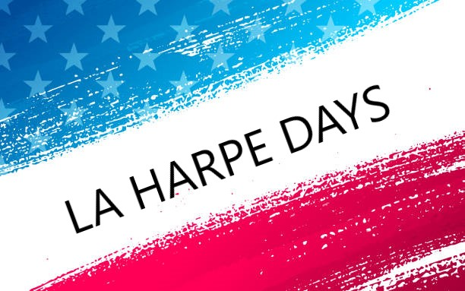

Now selling wristbands for the 2024 carnival! Buy early to take advantage of the savings!



**La Harpe Days: June 22, 2024!**

** *Follow us on Facebook for other events – La Harpe Days*

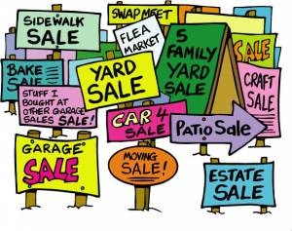

**City of LaHarpe City Wide Garage Sales**

**June 8th**

To be added to the list you must sign-up at city hall by 5:00 pm on

June 3rd

These lists will be available June 6th and may be picked up at the post office or the City Hall.

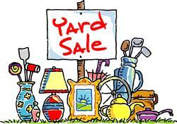



**June 20, 2024**

**You must sign-up at city hall before 5:00 pm on**

**Monday, June 17th to schedule your pickup.**

We need name, address, and list of items you want picked up.

**No tires, batteries, household trash or items with Freon.**

**Items must be out by the road by 8:00 a.m. Thursday, June 20th.**

**Please keep items separated in corresponding piles.**

**Dates to remember:**

May 8th: Council Meeting at City Hall at 7:00 pm

May 20th: PRIDE Meeting at 7:00 p.m. at the City Hall

 May 27th: City Hall closed in observance of Memorial Day

[](http://www.google.com/url?sa=i&rct=j&q=&esrc=s&source=images&cd=&cad=rja&uact=8&ved=0ahUKEwiI3_mmgoLLAhVW9mMKHe22Ar8QjRwIBw&url=http://www.paymentus.com/industry-utilities.html&psig=AFQjCNF-5ANx5SktbJug46KiWwMehsjzzw&ust=1455908868261283) May 29th: **Past due Utility shut off date.**

*If you can’t pay your account in* ***full*** *at this time then you must submit your reasoning to the City Clerk* ***BEFORE*** *May 29th.*

**CITY COUNCIL NEWS**

**CITIZENS CALL FOR BUSINESS**

1. Brandon Aiello requested a variance on the ordinance pertaining to the keeping of 3 dogs, and would like permission to keep one more dog above the three. Austin Lee made the motion to deny the request for granting a variance. Sharlyn Thompson seconded. Motion carried 4-0.

**UNFINISHED BUSINESS**

No business discussed.

**NEW BUSINESS**

1. Bruce Boettcher – Bruce shared contracts to get the sewer project under way. He shared the funding opportunities out there now will help pay for the engineering agreement. He suggested; the council could sign the agreement tonight and get things started now, or wait for approval on funding or just table the project until a later date. He reminded the council they have already been approved for the KDHE loan which would help with costs. Mayor Crowell asked if any funding was going to be available though CDBG. Bruce stated they will open up grant opportunities in September but only have about a million dollars available. Bruce reminded the council, this agreement is for the lift stations, not the collection system at this time and funding will be in place before bidding out the project. Danny Ware Jr made the motion to have the mayor sign the agreement and get started now. Ron Knavel seconded. Motion carried 5-0.
2. Tree Bids – One tree bid from Knight’s Tree Service was submitted for $30,000.00. Cayle Allen with Pempkes Tree Service was in attendance and shared with the council his quotes. He also stated the town looks pretty good from last time he was here trimming and suggest cutting over the top of the primary and secondary lines and removing small trees growing under the powerlines, doing so would cost the city $12,900.00. Mayor Crowell asked, if he ran into any other issues, what would the extra costs be. Cayle stated, it’s hard to give you a figure without knowing. Mayor Crowell suggested, if he sees issues make a list and we can get council together to discuss. Danny Ware Jr asked about a starting date. Cayle stated, probably within a month. Cynthia Carr made the motion to go with Cayle at a price of $12,900.00. Austin Lee seconded. Motion carried 5-0.
3. Roof Bids – Tabled to May
4. La Harpe Days Donation – La Harpe Days President, Joe Stotler, ask the city council if they would donate to La Harpe Days this year. He stated last year you donated $500.00 and we had 3 rides, this year we have 6 rides coming to town. Danny Ware Jr made the motion to donate $1,000.00 to La Harpe Days and take the money out of the fitness center. Ron Knavel seconded. Motion carried 5-0. Joe thanked the council and mentioned they could stop and see Michelle and she would get them a t-shirt.
5. La Harpe Days Beer Garden Request – Joe requested to have a beer garden in the park and shared that last year it went really well, no issues at all. He stated, last year a few had coolers but this year we will be asking for no coolers in hopes they support our vendors. Danny Ware Jr made the motion to allow a beer garden at La Harpe Days. Ron Knavel seconded. Motion carried 5-0.
6. Gym Floor – Danny ware asked how the grant on the floor was coming along because he talked to a guy that did a project for me and he works with a company from Canada and they have a rubberized floor paint that would work great and cut down on the echo in the gym. Mayor Crowell stated she talked to a Thrive grant writer and is looking into some possibilities.
7. Collections – Sharlyn Thompson asked what other cities were doing to collect money owed. Michelle stated our neighboring cities use Setoff, but I have reached out to CBK, Collection Bureau of Kansas, just waiting for a reply back.
8. Fitness Center – Sharlyn Thompson suggested raising the membership fee stating; we have purchased new equipment but have not raised the fee since we started the fitness center. Raising the fee could help with getting the gym floor done. Danny Ware Jr suggested he get a hold of the floor guy and get a quote and then look at fitness center fees after that.

**REPORTS OF CITY OFFICERS**

1. Fred Works, City Attorney – In regards to the animal that was dumped at ACARF, Fred suggested the council put something on the books about charging a fine for dumping an animal in the city of La Harpe, I just need to know if you want to change the code and if so, what amount of fine do you think it should be. Mayor Crowell suggested the maximum fine of $500.00. Fred also thought it would be a good idea to get a couple of good-sized signs that states dumping is not allowed and will be fined $500.00 if caught doing so. Joe suggested 2 signs at ACARF might help, he stated he would get a quote and bring back to council. Fred stated, on the Dustin Sinclair agreement I need to have a legal description, once I have that, I’ll have something ready for him. Fred suggested the city start writing citations for yards not in compliance, the city has 2 city wide cleanups every year with the first one coming up in June. If Penny issues citations, and they come to court, we can explain if the yard gets cleaned up the citation will be dismissed and then do this again in the fall when Pride has their cleanup.
2. Roy Caler, Water Representative – Nothing to report.
3. Joe Stotler, Police Chief – Shared his monthly time cards and report.
4. Penny Miller, Code/Animal Control –Shared her monthly reports. Penny shared to resolutions to condemn 310 W. 5th and 409 S. Jefferson. Austin Lee made the motion to approve resolution number 2024-2. Sharlyn Thompson seconded. Motion carried 5-0. Austin Lee made the motion to approve resolution number 2024-3. Sharlyn Thompson seconded. Motion carried 5-0. Mayor Crowell mentioned, she talked to county about changing speed limit on main for the school zone and the county commissioners would like a resolution. Austin Lee suggested the city get the flashing light signs, after looking at pricing, Fred suggested talking with the county or school districts about helping with the costs of those signs. Mayor Crowell stated she would contact the school superintendents. Mayor Crowell also shared that the crew has all of the fire hydrants working.
5. Marc Waggoner, Fire Chief- Absent from meeting. Monthly meeting minutes were shared: The La Harpe Volunteer Fire Department met for the monthly meeting. Present: Josh Sparks, Marc Waggoner Sr., Dennis Sidebottom, Ronald Splector, Kiefer Endicott, Bill Gay, Matthew Waggoner, and Justin Pritchard. Absent were, Pamela Waggoner and Meghan Sparks. La Harpe firefighters started meeting, took out trucks and did fire exercises, the welcomed Justin Pritchard to join the fire team, then ended the meeting. Gregg Geiler, resigned from the fire department.
6. Maintenance Department - The workorders and Dereck’s progress report were shared.
7. Michelle Altis, City Clerk – Asked the council if any of them would like the new 2024 Governing Body Handbook, the cost is $42.00 each. No one was interested in obtaining a copy.



***Mayor****: Ella Mae Crowell (620) 496-6219*

***City Attorney****: Fred Works*

***City Municipal Judge****: Patty Miklos*

***Police Chief****: Joseph Stotler*

***Fire Chief****: Marc Waggoner*

***Assistant Fire Chief****: Dennis Sidebottom*

***City Clerk****: Michelle Altis*

***Assistant Clerk****: Teresa Driskel*

***City Treasurer****: Audra Riggins*

***Maintenance Staff****: Dereck Ranes, Larry Laird & Keanen Badders*

***Code & Animal Control****: Penny Miller*

***City Council Members:***

***Austin Lee (496-2323) Danny Ware Jr. (496-2156)***

***Cynthia Carr (496-7500) Sharlyn Thompson (496-3348)***

***Ron Knavel (496-2508)***

***Laharpe City Hall Hours: Monday-Friday***

902 S. Washington 8:00-12:00 & 1:00-5:00

P.O. Box 10 Ph. (620) 496-2241

Laharpe, KS. 66751 Fax (620) 496-2240

***CHECK OUT OUR WEBSITE; CITYOFLAHARPE.ORG*** ** *Follow us on Facebook – City of La Harpe*

# 

# Taco Cornbread Casserole

## Ingredients

* 2 pounds ground beef
* 2 envelopes taco seasoning
* 2 cans (14-1/2 ounces each) diced tomatoes, drained
* 1 cup water
* 1 cup cooked rice
* 1 can (4 ounces) chopped green chiles
* 2 packages (8-1/2 ounces each) cornbread/muffin mix
* 1 can (8-3/4 ounces) whole kernel corn, drained
* 1 cup sour cream
* 2 cups corn chips
* 2 cups shredded Mexican cheese blend or cheddar cheese, divided
* 1 can (2-1/4 ounces) sliced ripe olives, drained
* Optional: Shredded lettuce, chopped tomatoes and chopped red onion

## Directions

* **1.** Preheat oven to 400°. In a Dutch oven, cook beef over medium heat until no longer pink, 8-10 minutes, breaking it into crumbles; drain. Stir in taco seasoning. Add tomatoes, water, rice and green chiles; heat through, stirring occasionally.
* **2.** Meanwhile, prepare the cornbread mix according to package directions; stir in corn. Pour half the batter into a greased 13x9-in. baking dish. Layer with half the meat mixture, all the sour cream, half the corn chips and 1 cup cheese. Top with the remaining batter and meat mixture, and the olives.
* **3.** Bake, uncovered, until the cornbread is cooked through, 55-60 minutes. Sprinkle with remaining 1 cup corn chips and 1 cup cheese; bake until cheese is melted, 3-5 minutes longer. If desired, serve with lettuce, tomatoes and red onion.

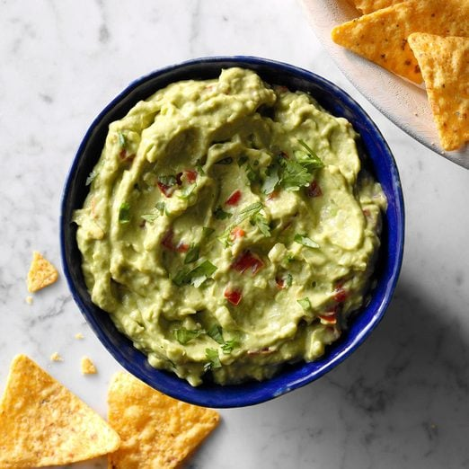

**Homemade Guacamole**

## Ingredients

* 3 medium ripe avocados, peeled and cubed
* 1 garlic clove, minced
* 1/4 to 1/2 teaspoon salt
* 1 small onion, finely chopped
* 1 to 2 tablespoons lime juice
* 1 tablespoon minced fresh cilantro
* 2 medium tomatoes, seeded and chopped, optional
* 1/4 cup mayonnaise, optional

## Directions

* **1.** Mash avocados with garlic and salt. Stir in remaining ingredients, adding tomatoes and mayonnaise if desired.



# Easy Strawberry Lemonade Freezer Pie

## Ingredients

* 1 container (23.2 ounces) frozen sweetened sliced strawberries, thawed (2-1/2 cups thawed)
* 1 package (3.4 ounces) instant lemon pudding mix
* 1 carton (8 ounces) frozen whipped topping, thawed
* 1 graham cracker crust (9 inches)
* Optional: Additional whipped topping and fresh strawberries

## Directions

* **1.** In a large bowl, combine strawberries (with juices) and pudding mix; let stand until slightly thickened, about 5 minutes. Fold in whipped topping. Spread into crust.
* **2.** Freeze at least 8 hours or overnight. Let stand 5-10 minutes before serving. If desired, serve with additional whipped topping and fresh strawberries.



# Chocolate Billionaires

## Ingredients

* 1 package (14 ounces) caramels
* 3 tablespoons water
* 1-1/2 cups chopped pecans
* 1 cup Rice Krispies
* 3 cups milk chocolate chips
* 1-1/2 teaspoons shortening

## Directions

* **1.** Line 2 baking sheets with waxed paper; grease the paper and set aside. In a large heavy saucepan, combine the caramels and water; cook and stir over low heat until smooth. Stir in pecans and cereal until coated. Drop by teaspoonfuls onto prepared pans. Refrigerate for 10 minutes or until firm.
* **2.** Meanwhile, in a microwave, melt chocolate chips and shortening; stir until smooth. Dip candy into chocolate, coating all sides; allow excess to drip off. Place on prepared pans. Refrigerate until set. Store in an airtight container.