DECEMBER NEWSLETTER



 *Even though it was only September, the air was crisp and children were already whispering about Christmas plans and Santa Claus. It made the already long months until Christmas seem even longer. With each passing day the children became more anxious, waiting for that final school bell. Upon ringing everyone would run for coats, gloves, and the classroom door, racing to see who would be the first one home: everyone except David.*

*David was a small boy with messy brown hair and tattered clothes. I had often wondered what kind of mother could send her son to school dressed so inappropriately for the cold winter months without a coat, boots, or gloves. But something made David special. It wasn’t his intelligence or manners for they were as lacking as his winter clothes, but I can never recall looking at David and not seeing a smile. He was always willing to help and not a day passed that David didn’t stay after school to straighten the chairs and clean erasers. We never talked much, he would simply smile and ask what else he could do, then thank me for letting him stay and slowly head for home.*

*Weeks passed and the excitement over the coming Christmas grew into restlessness until the last day of school before the holiday break. I can’t recall a more anxious group of children as that final bell rang and they scattered out the door. I smiled in relief as the last of them hurried out. Turning around I saw David quietly standing by my desk.*

#### “Aren’t you anxious to get home David? I asked.

#### “No.” he quietly replied.

#### Ready to go home myself I said, “Well, I think the chairs and erasers will wait why don’t you hurry home.”

#### “I have something for you,” he said. He pulled from behind his back a small box wrapped in old paper and tied with a string. Handing it to me he said anxiously, “Open it!”

#### I took the box from him, thanked him and slowly unwrapped it. I lifted the lid and to my surprise saw nothing. I looked at David’s smiling face and back into the empty box and said, “this box is nice David, but it’s empty.”

#### “Oh no it isn’t,” said David. “It’s full of love. My mom told me before she died that love was something you couldn’t see or touch unless you know it’s there…can you see it?”

#### Tears filled my eyes as I looked at the proud dirty face, I had rarely given attention. “Yes, David. I can see it.” I replied. “Thank you.”

#### David and I became good friends after that Christmas and I can say that with the passing years, I never again let the uncombed hair or dirty faces bother me, and I never forgot the meaning behind the little empty box that sat on my desk.”



#### 

***"A Letter from Santa Claus" by Mark Twain***

*My Dear Susie Clemens,*

*I have received and read all the letters which you and your little sister have written me...I can read your and your baby sister's jagged and fantastic marks without any trouble at all. But I had trouble with those letters which you dictated through your mother and the nurses, for I am a foreigner and cannot read English writing well. You will find that I made no mistakes about the things which you and the baby ordered in your own letters—I went down your chimney at midnight when you were asleep and delivered them all myself--and kissed both of you, too...But...there were...one or two small orders which I could not fill because we ran out of stock...*

*There was a word or two in your mama's letter which...I took to be "a trunk full of doll's clothes." Is that it? I will call at your kitchen door about nine o'clock this morning to inquire. But I must not see anybody and I must not speak to anybody but you. When the kitchen doorbell rings, George must be blindfolded and sent to the door. You must tell George he must walk on tiptoe and not speak—otherwise he will die someday. Then you must go up to the nursery and stand on a chair or the nurse's bed and put your ear to the speaking tube that leads down to the kitchen and when I whistle through it you must speak in the tube and say, "Welcome, Santa Claus!" Then I will ask whether it was a trunk you ordered or not. If you say it was, I shall ask you what color you want the trunk to be...and then you must tell me every single thing in detail which you want the trunk to contain. Then when I say "Good-by and a merry Christmas to my little Susy Clemens," you must say "Good-by, good old Santa Claus, I thank you very much." Then you must go down into the library and make George close all the doors that open into the main hall, and everybody must keep still for a little while.*

*I will go to the moon and get those things and in a few minutes I will come down the chimney that belongs to the fireplace that is in the hall—if it is a trunk you want--because I couldn't get such a thing as a trunk down the nursery chimney, you know...If I should leave any snow in the hall, you must tell George to sweep it into the fireplace, for I haven't time to do such things. George must not use a broom, but a rag—else he will die someday...If my boot should leave a stain on the marble, George must not holystone it away. Leave it there always in memory of my visit; and whenever you look at it or show it to anybody you must let it remind you to be a good little girl. Whenever you are naughty and someone points to that mark which your good old Santa Claus's boot made on the marble, what will you say, little sweetheart?*

*Good-by for a few minutes, till I come down to the world and ring the kitchen doorbell.*

*Your loving Santa Claus  
Whom people sometimes call  
"The Man in the Moon"*





***Sock Gnomes***

**Instructions**

**Prep Time:**30 minutes

**Supplies**

* 1 Patterned Crew Sock *adult size*
* 1 Solid Color Crew Sock *adult size*
* 1 9 inch Cone
* 1 4 x 4-inch Piece of Faux Fur
* 1 1.25-inch Wood Bead
* Hot Glue Gun
* Holiday Decorations (buttons, felt piece, etc.) *optional*

**Instructions**

* Cut off the bottom (toe part) of a solid-colored sock, just past the heel (as shown below). Pull the sock over the bottom of the cone and pull it up so it covers the lower 5 inches of the cone. Use hot glue to secure the top of the sock to the cone.

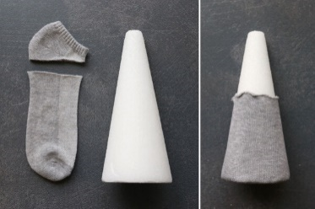

* Cut out a beard from fur. It’s easiest to draw the beard shape on the back of the fur. Cut the beard about 3.25 inches tall and 2.75 inches wide. When cutting fur, you DO NOT want to just use scissors and cut it out like you would any other fabric because then the fur along the edges of the beard will be very short. To make sure you get the long “beard” effect on the fur, you have two options. First, you can use a razor blade or exacto knife and cut from the back of the fur, cutting through the backing only. Second, you can use sharp scissors, but you’ll want to cut with the back of the fur facing you, and slide the bottom of your scissor through the fur very close to the backing. Your goal is to just cut the backing, not any of the fur itself. Place the beard on the sock at the 4.5-inch mark, or halfway up the cone. Hot glue the beard to the sock.

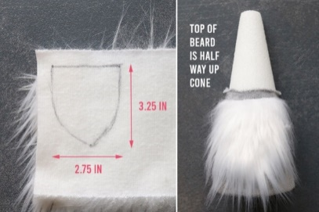

* Hot glue a bead onto the beard as shown below. Note that the bead is only touching beard, not sock.

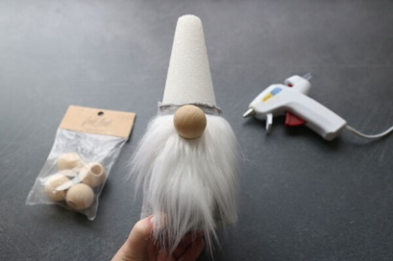

* Make the hat. Turn the patterned sock inside out. If sewing, pin a diagonal line as you see below, then sew along it and trim about 1/2 an inch away from the line you sewed. I used a serger here, but a regular sewing machine works just fine. Just set the stitch length a bit longer than normal and try not to stretch the sock as you sew. Alternately, if you don’t want to sew, you can mark a diagonal line as you see in the photo. Cut about 1/2 an inch to the right of it. Glue the right sides of the sock together along the cut line.

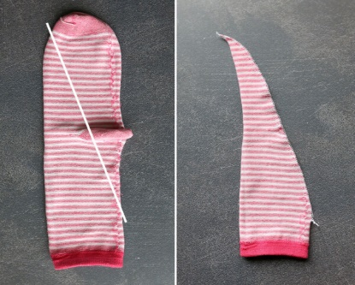

Turn the sock right side out, then place it over top of the cone as a hat. The sock will stick to the cone as you place it on, so it will take a minute to pull it on. Watch the video to see the easiest way to do this. Decorate the hat with holiday shaped buttons, felt pieces, jingle bells, etc., if desired.

**COLOR ME FOR CHRISTMAS!!** 



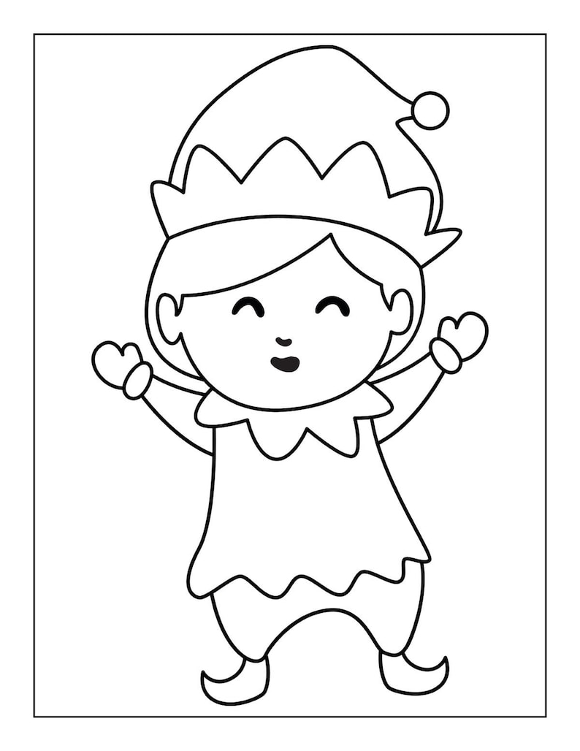



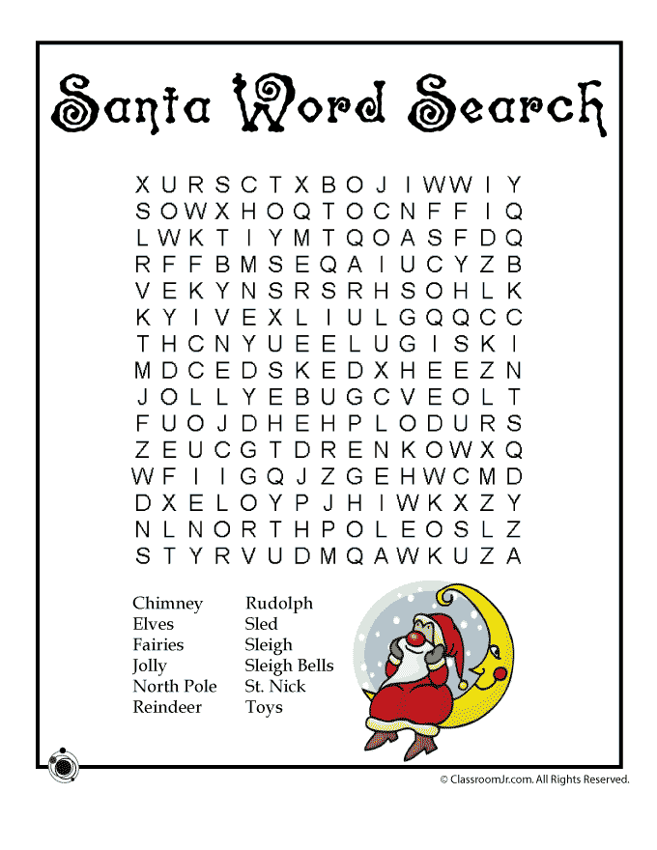

LOCAL NEWS

* Are you in need of grocery delivery service? Call 620-228-5570 for more information on this new service.
* La Harpe Days T-Shirts available at City Hall.
* Coles Trash Service will pick-up Thursday, December 26th instead of Wednesday, December 25th.

**If you need assistance after-hours please call the Iola Dispatch Center at (620) 365-1437, they will notify the proper personnel.**

 HAPPY BIRTHDAY TO ALL LAHARPE CITIZENS CELEBRATING A BIRTHDAY THIS MONTH!!!! MAY YOUR DAY BE AS SPECIAL AS YOU ARE TO US!

[](https://www.google.com/url?sa=i&rct=j&q=&esrc=s&source=images&cd=&cad=rja&uact=8&ved=2ahUKEwi_8Lzk8v7lAhVVJzQIHbAnBIsQjRx6BAgBEAQ&url=%2Furl%3Fsa%3Di%26rct%3Dj%26q%3D%26esrc%3Ds%26source%3Dimages%26cd%3D%26ved%3D%26url%3Dhttps%253A%252F%252Fwww.whychristmas.com%252Fcustoms%252Fcandycanes.shtml%26psig%3DAOvVaw1EQjFDus21tLccxv3oC0m3%26ust%3D1574549136825070&psig=AOvVaw1EQjFDus21tLccxv3oC0m3&ust=1574549136825070)

**Dates to remember:**

December 11th: Council Meeting at City Hall At 7:00 P.M.

 December 16TH: PRIDE Meeting at 7:00 p.m. at the City Hall

 December 25th: City Hall will be Closed. City Hall will also be closed on Christmas eve, December 24th.



**The city staff would like to wish everyone a *VERY MERRY CHRISTMAS!!***

[](http://www.google.com/url?sa=i&rct=j&q=&esrc=s&source=images&cd=&cad=rja&uact=8&ved=0ahUKEwiI3_mmgoLLAhVW9mMKHe22Ar8QjRwIBw&url=http://www.paymentus.com/industry-utilities.html&psig=AFQjCNF-5ANx5SktbJug46KiWwMehsjzzw&ust=1455908868261283)December 27th: **Past due Utility shut off date.**

*If you can’t pay your account in* ***full*** *at this time then you must submit your reasoning to the City Clerk* ***BEFORE*** *December 27th.*

**CITY COUNCIL NEWS**

**CITIZENS CALL FOR BUSINESS**

1. Citizen, Tim Farmer, addressed the council asking if the city was losing Joe. Mayor Crowell stated, he turned in his resignation and we can’t keep him if he doesn’t want to stay. Tim stated; there are some good employees in this city, I feel safe living in this city now but to go without a cop is not good at all. This community wants good people, good neighbors and good businesses and we won’t have any of it without a good cop. I am just a very concerned citizen that is trying to help in protecting our city. Mayor Crowell thanked him for sharing his opinion.
2. Tori Riebel with the SEK Health Department attended to introduce herself to the community and to share a few things the health department offers; immunizations, physicals, family planning, WIC, and lots of other sources. She stated they are doing a flu clinic here at city hall tomorrow from 8am to 10am and will also be offering RSV shots as well.

**UNFINISHED BUSINESS**

1. Employee Insurance Benefits – Tabled to December

**NEW BUSINESS**

1. KMEA Solar Project – Neal Daney with KMEA presented the council a project from Ninnescah Flats Solar, stating the city have a couple of contracts coming due in 2027. He shared the solar project will help stabilize the electric rates, he is estimating it to cover about 20% of the city’s energy needs. This solar project is located in Pratt County, about 70 miles west of Wichita. Danny Ware Jr asked who is funding this project. Neal stated a company called NextEra is in charging of building and funding of this project. The council agreed to review the material and make a decision at the December meeting.
2. Kwikom Business Phones – Tabled until December
3. Kennel Fees – Sharlyn Thompson suggested looking at our kennel fees because of the money, food and water we put into it each time we have dogs there. Mayor Crowell asked Penny to check with other cities and see what they charge and bring back in December.
4. Court Costs – Sharlyn Thompson asked how La Harpe compares with other cities. Fred stated, La Harpe is in the middle and wouldn’t recommend raising them at this time. No other action was taken on this matter.
5. Electric Help – Ron Knavel expressed concerns about having someone with knowledge available to help the city. Mayor Crowell stated we have been using Curt Jackson and Jim Baker, with the City of Iola, said we could reach out to him anytime. Ron asked if Curt would help let our employees know what they need. Penny Stated he has been very helpful. Mayor Crowell said the crew has been replacing anything they have used so that we don’t run out.
6. Border States Quote – A quote was shared to buy wire, light fixtures and light eyes from Border states in the amount of $2,228.33. Mayor Crowell suggested Larry get with Jeff Cook on pricing before ordering. Sharlyn Thompson made the motion to get the supplies from Border States in the amount of $2,228.33

unless Jeff Cook is cheaper than go through him. Ron Knavel seconded. Motion carried 5-0.

1. FEMA Money – Joe shared a printout of FEMA money the city has and will be receiving; $11,000.38 went into our working funds for debris removal, $5,642.31 is in our electric upgrade but Michelle noted it was titled incorrectly when first sent and it should be in our sewer fund so need a motion to move to correct account, and we should be receiving $14,471.89 that will go to the electric upgrade fund for damage to utility poles. Danny Ware Jr made the motion to move the money from electric upgrade to the sewer upgrade fund. Sharlyn Thompson seconded. Motion carried 5-0.
2. Roof Contract – Mayor Crowell stated we do not have any leaks, Travis patched those when he worked here and Penny stated she did not see anything new. Fred suggested we honor the contract next spring, if you withdrawal from the contract now you’ll end up paying more next year. Council agreed to move forward on the roof repair in the spring.
3. Thanksgiving / Christmas Employees – Mayor Crowell stated; last year you made the motion to give full time $150.00 and part time $100.00 with taxes withheld and checks issued December 1st. Danny ware Jr made the motion to do the same thing as last year. Sharlyn Thompson seconded. Motion carried 5-0.

**REPORTS OF CITY OFFICERS**

1. Fred Works, City Attorney – Nothing to report.
2. Roy Caler, Water Representative – Nothing to report.
3. Joe Stotler, Police Chief – Shared his monthly time cards and report.
4. Penny Miller, Code/Animal Control –Shared her monthly reports. Mayor Crowell stated we passed our kennel inspection this time, we are still working on the appeal. Penny stated she needs to buy metal buckets instead of rubber or plastic.
5. Marc Waggoner, Fire Chief- Shared the fire meeting minutes; Present: Josh Sparks, Marc Waggoner Sr., Kiefer Endicott, Matthew Waggoner, Dennis Sidebottom, Bill Gay, and Meghan Sparks. Absent were Pamela Waggoner, Ronald Splector and Justin Pritchard. Started meeting, had discussion about hazardous materials on fires and precaution to keep from getting injured, then ended meeting. Danny Ware Jr asked Marc why the fire trucks had no hose on them. Marc stated all the trucks have hoses; some are in the side compartments.
6. Maintenance Department - The workorders were shared. A bid from Pempke’s Tree Service in the amount of $3,500.00 for him to come finish. Michelle stated he could start at the end of November or first part of December. Ron Knavel made the motion to accept the bid. Sharlyn Thompson seconded. Motion carried 5-0.
7. Michelle Altis, City Clerk – Michelle shared with the council a letter and invoice that was being sent to the property owner where the tree fell and broke a city pole in half.



***Mayor****: Ella Mae Crowell (620) 496-6219*

***City Attorney****: Fred Works*

***City Municipal Judge****: Patty Miklos*

***Police Chief****:*

***Fire Chief****: Marc Waggoner*

***Assistant Fire Chief****: Dennis Sidebottom*

***City Clerk****: Michelle Altis*

***Assistant Clerk****: Teresa Driskel*

***City Treasurer****: Audra Riggins*

***Maintenance Staff****: Larry Laird & Penny Miller*

***Code & Animal Control****: Penny Miller*

***City Council Members:***

***Angela Barker (224-6209) Danny Ware Jr. (496-2156)***

***Cynthia Carr (496-7500) Sharlyn Thompson (496-3348)***

***Ron Knavel (496-2508)***

***Laharpe City Hall Hours: Monday-Friday***

902 S. Washington 8:00-12:00 & 1:00-5:00

P.O. Box 10 Ph. (620) 496-2241

Laharpe, KS. 66751 Fax (620) 496-2240

# *CHECK OUT OUR WEBSITE; CITYOFLAHARPE.ORG* *Follow us on Facebook*



# Breakfast Casserole

**Ingredients**

1. 1 pound bulk pork sausage
2. 6 large eggs
3. 2 cups 2% milk
4. 1 teaspoon salt
5. 1 teaspoon ground mustard
6. 6 slices white bread, cut into 1/2-inch cubes
7. 1 cup shredded cheddar cheese

**Directions**

1. In a skillet, brown and crumble sausage; drain and set aside. In a large bowl, beat eggs; add milk, salt and mustard. Stir in bread cubes, cheese and sausage.
2. Pour into a greased 11x7-in. baking dish. Cover and refrigerate for 8 hours or overnight. Remove from the refrigerator 30 minutes before baking. Bake, uncovered, at 350° for 40 minutes or until a knife inserted in center comes out clean.



**White Chicken Chili**

**Ingredients**

1 pound boneless skinless chicken breasts, chopped

1 medium onion, chopped

1 tablespoon olive oil

2 garlic cloves, minced

2 cans (14 ounces each) chicken broth

1 can (4 ounces) chopped green chiles

2 teaspoons ground cumin

2 teaspoons dried oregano

1-1/2 teaspoons cayenne pepper

3 cans (14-1/2 ounces each) great northern beans, drained, divided

1 cup shredded Monterey Jack cheese

Optional: sliced jalapeno pepper, sour cream and crispy tortilla strips

**Directions**

1. In a Dutch oven over medium heat, cook chicken and onion in oil until lightly browned. Add garlic; cook 1 minute longer. Stir in the broth, chiles, cumin, oregano and cayenne; bring to a boil.
2. Reduce heat to low. With a potato masher, mash 1 can of beans until smooth. Add to saucepan. Add remaining beans to saucepan. Simmer for 20-30 minutes or until chicken is no longer pink and onion is tender.
3. Top each serving with cheese and, if desired, jalapeno pepper, sour cream and tortilla strips.



**Homemade Eggnog**

**Ingredients**

* 12 large eggs
* 1-1/2 cups sugar
* 1/2 teaspoon salt
* 8 cups whole milk, divided
* 2 tablespoons vanilla extract
* 1 teaspoon ground nutmeg
* 2 cups heavy whipping cream
* Additional nutmeg, optional

**Directions**

1. In a heavy saucepan, whisk together eggs, sugar and salt. Gradually add 4 cups milk; cook and stir over low heat until a thermometer reads 160°-170°, 30-35 minutes. Do not allow to boil. Immediately transfer to a large bowl.
2. Stir in vanilla, nutmeg and remaining milk. Place bowl in an ice-water bath, stirring until milk mixture is cool. (If mixture separates, process in a blender until smooth.) Refrigerate, covered, until cold, at least 3 hours.
3. To serve, beat cream until soft peaks form. Whisk gently into cooled milk mixture. If desired, sprinkle with additional nutmeg before serving.

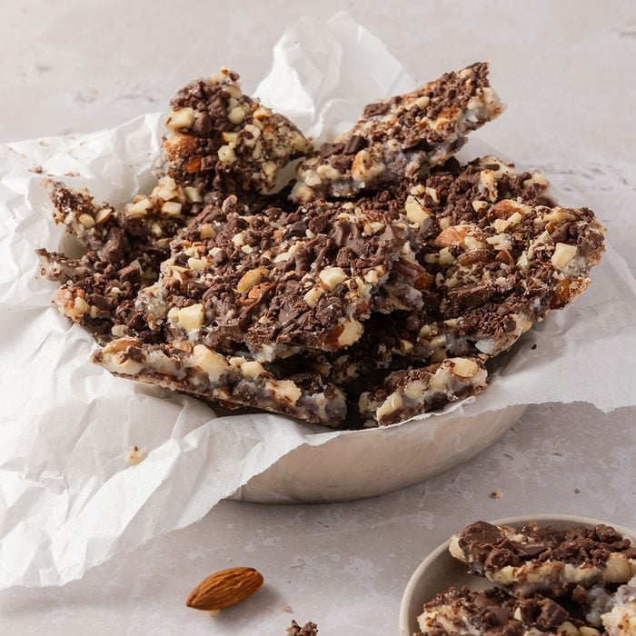

**Aunt Rose’s Fantastic Butter Toffee**

**Ingredients**

* 2 cups unblanched whole almonds
* 11 ounces milk chocolate, chopped
* 1 cup butter, cubed
* 1 cup sugar
* 3 tablespoons cold water

**Directions**

* Preheat oven to 350°. In a shallow baking pan, toast almonds until golden brown, 5-10 minutes, stirring occasionally. Cool. Pulse chocolate in a food processor until finely ground (do not overprocess); transfer to a bowl. Pulse almonds in food processor until coarsely chopped. Sprinkle 1 cup almonds over bottom of a greased 15x10x1-in. pan. Sprinkle with 1 cup chocolate.
* In a heavy saucepan, combine butter, sugar and water. Cook over medium heat until a candy thermometer reads 290° (soft-crack stage), stirring occasionally.

## Immediately pour mixture over almonds and chocolate in pan. Sprinkle with remaining chocolate and almonds. Refrigerate until set; break into pieces.



**Appetizer Wreath**

**Ingredients**

* 2 tubes (8 ounces each) refrigerated crescent rolls
* 1 package (8 ounces) cream cheese, softened
* 1/2 cup sour cream
* 1 teaspoon dill weed
* 1/8 teaspoon garlic powder
* 1-1/2 cups chopped fresh broccoli florets
* 1/2 cup finely chopped sweet red pepper
* 1 cup finely chopped celery
* Celery leaves

**Directions**

1. Remove crescent dough from packaging (do not unroll). Cut each tube into 8 slices. Arrange in an 11-in. circle on an ungreased 14-in. pizza pan.
2. Bake at 375° for 15-20 minutes or until golden brown. Cool for 5 minutes before carefully removing to a serving platter; cool completely.
3. In a small bowl, beat the cream cheese, sour cream, dill and garlic powder until smooth. Spread on wreath; top with broccoli, red pepper, chopped celery and celery leaves.

Twas the night before Christmas, when all through the house  
Not a creature was stirring, not even a mouse.  
The stockings were hung by the chimney with care,  
In hopes that St Nicholas soon would be there.  
  
The children were nestled all snug in their beds,  
While visions of sugar-plums danced in their heads.  
And mamma in her ‘kerchief, and I in my cap,  
Had just settled our brains for a long winter’s nap.  
  
When out on the lawn there arose such a clatter,  
I sprang from the bed to see what was the matter.  
Away to the window I flew like a flash,  
Tore open the shutters and threw up the sash.  
  
The moon on the breast of the new-fallen snow  
Gave the lustre of mid-day to objects below.  
When, what to my wondering eyes should appear,  
But a miniature sleigh, and eight tinny reindeer.  
  
With a little old driver, so lively and quick,  
I knew in a moment it must be St Nick.  
More rapid than eagles his coursers they came,  
And he whistled, and shouted, and called them by name!  
  
"Now Dasher! now, Dancer! now, Prancer and Vixen!  
On, Comet! On, Cupid! on, on Donner and Blitzen!  
To the top of the porch! to the top of the wall!  
Now dash away! Dash away! Dash away all!"  
  
As dry leaves that before the wild hurricane fly,  
When they meet with an obstacle, mount to the sky.  
So up to the house-top the coursers they flew,  
With the sleigh full of Toys, and St Nicholas too.

And then, in a twinkling, I heard on the roof  
The prancing and pawing of each little hoof.  
As I drew in my head, and was turning around,  
Down the chimney St Nicholas came with a bound.  
  
He was dressed all in fur, from his head to his foot,  
And his clothes were all tarnished with ashes and soot.  
A bundle of Toys he had flung on his back,  
And he looked like a peddler, just opening his pack.  
  
His eyes-how they twinkled! his dimples how merry!  
His cheeks were like roses, his nose like a cherry!  
His droll little mouth was drawn up like a bow,  
And the beard of his chin was as white as the snow.  
  
The stump of a pipe he held tight in his teeth,  
And the smoke it encircled his head like a wreath.  
He had a broad face and a little round belly,  
That shook when he laughed, like a bowlful of jelly!  
  
He was chubby and plump, a right jolly old elf,  
And I laughed when I saw him, in spite of myself!  
A wink of his eye and a twist of his head,  
Soon gave me to know I had nothing to dread.  
  
He spoke not a word, but went straight to his work,  
And filled all the stockings, then turned with a jerk.  
And laying his finger aside of his nose,  
And giving a nod, up the chimney he rose!  
  
He sprang to his sleigh, to his team gave a whistle,  
And away they all flew like the down of a thistle.  
But I heard him exclaim, ‘ere he drove out of sight,  
"Happy Christmas to all, and to all a good-night!" 

